E=mc^2
- to calculate the extra energy of the binding force inside the nucleus

nuclear = comes from the nucleus, the energy inside of a nucleus , it's to say, (say how intimidating the idea of nuclear energy and the word nuclear),IT'S JUST TALKING ABOUT THE ENERGY THAT IS INSIDE OF A NUCLEUS
Most of the changess always happe with the valance electrons, but the changes that happen in the nucleus, well thats nuclear energy

u = unified atomic mass unit, used to meause mass in the atom, a physical constant that is accepeted for use in the SI messuerment s ystem
- U = 1.6605 x 10^-27 kg

unstable atom = called a radioisetope, and since it's uncomterable with so much energy, it tries to loose some, using radioactive decay

it's important to know the masses of differnt nuclei since nuclear interactions are all about mass-energy convertions

since the total mass of a stable nucleus is always less than that of the total mass of individual protrons and neutrons put together, you must use E=MC^2 to calculate the difference
- the difference, is the binding energy of the nucleus

strong nuclear force = the attractive force that acts between protrons and neutrons in a nucleus
- strong enough to act agains the repution of protrons inside the nucleus, but only acts over small distances
- the electronmagenic force works over larger distances
- and due to this low distance, loads of neutrons are needed to bind the nucleus together when lot's of protrons are present

see chart = explains the stability of an atom
- when an atom is unstable and falls apart into lower orbits or elements is what we call radioctivity

radioctivity = the decay of unstable nuclei + the realese of energetic particles is radioctivity
- there's 3 types, alpha, beta, and gamma
alpha decay = is released when an nunstable nucleus loses two protrons and two neutrons, becoming a different element in the process
- parent nucleus(original unstable one) = turns into a daughter nucleus + alpha particle (++ and two neutrons) (the nucleus of a helium atom)
- occurs because the parent nucleus is too large and the strong nuclear force is no longer strong enough to hold all of it together
- when transmutating, there is always less mass when mesured in u, becuase you lost some kenetic energy in the process, this energy is the one used in nuclear energy
- alpha is the weakest of all forces, beraly being able to pass through a pice of paper
- the kenetic energy, is what's used to power nuclear plants

transmutation = the process of turning from one elment into another
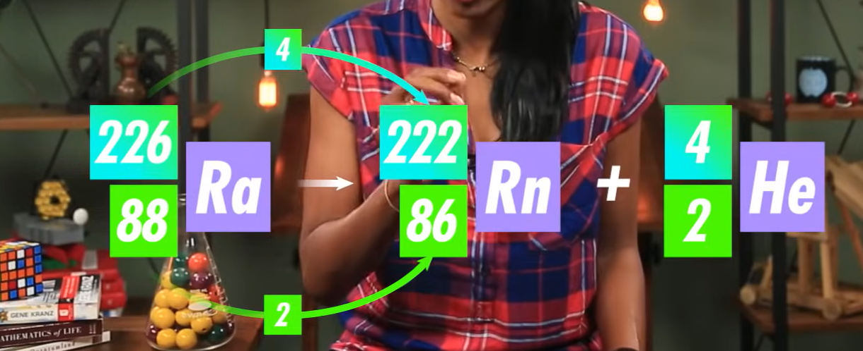

beta decay = when an unstable nucleus emits a beta particle, which is just an electron
- it also releases a neutrono in this case
- neutrino = a very small, neutrally charged particle
    - it's excistence is proven by the conservation of energy
    - the electrons from beta decay have been found to have energies which vary greatly, which infers and leads the way to the neutrino , which happen to carry away that extra energy
- beta decay is caused by the weak force
- beta particles are usually stopped by a few millimiters of thin alumminun
- transmutation still happens
the weak force = the force that acts on quarks, what makes up everything

gamma decay = results when a nucleus emits high-powered photons, in what are known as gamma rays
- can happen when the nucleus is decaying form a larger form and is in an excited state, and because it collided with a high energy particle
- no transmutation occurs, just releases an alpha particle

when a nucleus is excited, it wants to transition into a lower energy state, which happens by realesing a photon

radiation = the release of energy in the form of moving waves, or streams of particels
- can be low level(microwave/ cellphones)(non-ionizing) or high level(x-ray / cosmic radiation)(ionizing)

ionizing radiation = radiation that has enough energy to remove an electron from an atom or molecule, causing it to become ionized

half-life= the amount of time it takes for half of the atoms to decay

(for when talking about radiation in medical puroposes), talk about how PET CAT and x-rays all use it

